BLOCKCHAIN-ENABLED WILLS AND TESTAMENTS:

The transformative potential of blockchain technology is poised to revolutionize the longstanding practice of executing wills. By leveraging this technology, a decentralized ledger of wills could be established, ensuring a secure repository for a testator's intentions regarding the distribution of assets after their passing. Through the implementation of blockchain, an accurate, verifiable, and protected record of a testator's final wishes for asset disposition can be maintained [1]. This research advocates for the development of an encrypted blockchain specifically designed to enhance the safety of wills, thereby mitigating the risks of loss or unauthorized alteration. While this cutting-edge technology may pose challenges to existing statutory laws, it presents a tangible and realistic legal approach on the horizon.

​

​

Problem Statement

As Blockchain technology continues to gain traction, it is widely expected that a significant portion of legal services will transition to online platforms. Ensuring that these new digital platforms possess the same essential characteristics as their traditional counterparts becomes imperative. Consequently, this research undertakes an analysis of the attributes of both blockchain technology and Will construction (Fig.1) to propose a viable platform known as Crypto-Wills (Fig. 2), empowered by Smart Contracts. The following are notable features of Blockchain:

1. Data tracking and storage: By decentralizing data, blockchain minimizes the risk of data tampering or manipulation.
2. Trust in data: With its inherent resistance to hacking, blockchain offers a secure platform for storing sensitive information and documents [2].
3. Elimination of intermediaries: The peer-to-peer nature of blockchain interactions has the potential to revolutionize how we access, verify, and transact with one another.

Together, these features lay the foundation for a robust and efficient online platform, shaping the future of legal services in alignment with the transformative capabilities of blockchain technology.

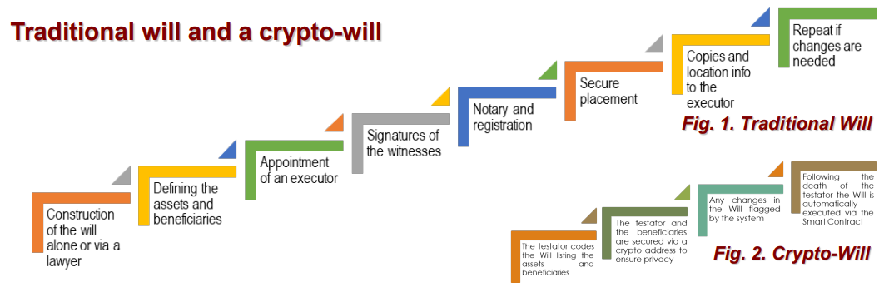

Features of a Will

Characteristics of a Will include:

1. The Will must be documented in writing.
2. The testator has the freedom to create a Will at any point during their lifetime.
3. The Will can be modified multiple times, without any legal restrictions on the number of alterations.
4. The testator holds the authority to revoke the Will at any time while they are alive.
5. The Will necessitates the presence of two or more witnesses who have witnessed the testator's signing.
6. The testator appoints an executor who is granted the power to distribute assets in accordance with the testator's wishes.
7. Registering the Will is mandatory, as it provides substantial legal evidence of its validity. Registration ensures the Will's security, preventing tampering, destruction, mutilation, or theft.
8. The Will is only released to the testator or, in the event of their death, to the executor upon the presentation of a Death Certificate.
9. The Will is legally enforceable solely following the testator's death.

**Proposed Crypto-Will Platform**

The proposed steps for a Crypto-Will, as outlined in this study (Fig. 3), are as follows:

1. The testator encodes their Will, listing their assets and beneficiaries.
2. Both the testator and beneficiaries are secured using crypto addresses to ensure privacy.
3. The assets held by designated entities are linked with a smart contract, enabling the seamless transfer of assets to beneficiaries upon the testator's demise. For example, upon the testator's death, the smart contract will automatically notify the bank to transfer liquid assets to the appropriate beneficiary.
4. The Crypto-Will incorporates a dual-layer screening system: i. The Will is connected to a national database that records births and deaths. When the testator's death is recorded, the blockchain triggers the execution of the Crypto-Will. ii. The Crypto-Will is also linked to an alert software program that periodically sends notifications to the testator, requiring a response to confirm their living status. If a specific number of notifications go unanswered, the software verifies the testator's death.
5. The Crypto-Will will only be executed when both of these programs independently confirm the testator's death. This two-layer approach ensures the tamper-proof nature of the Crypto-Will.
6. Any modifications made to the Crypto-Will by the testator will be flagged by the system.
7. Upon the testator's death, the Crypto-Will is automatically executed through the implementation of a Smart Contract.

**Use Case Niches**

In order to ensure the success of the project, identifying a specific niche is crucial. The following areas can be targeted as initial priorities:

1. Military Wills: Streamlining the pre and post-deployment processes for military personnel.
2. POA (Power of Attorneys): Developing solutions to facilitate efficient and secure power of attorney processes.
3. Governmental Employees: Providing tailored services for government employees to manage their wills and estate planning.
4. State and Local Governmental Agencies: Offering solutions to assist state and local agencies in managing and executing wills.
5. Law Firms: Collaborating with law firms to integrate Crypto-Will technology into their practice.

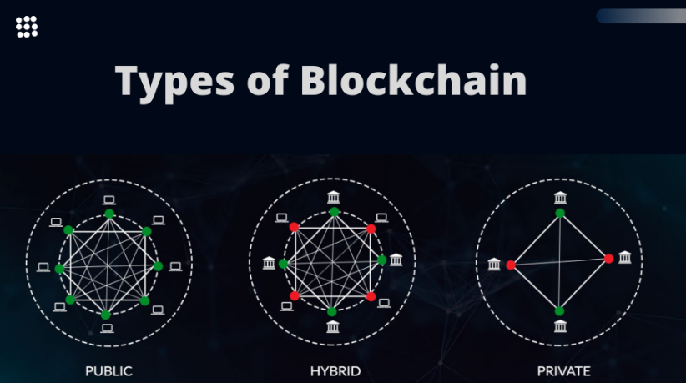

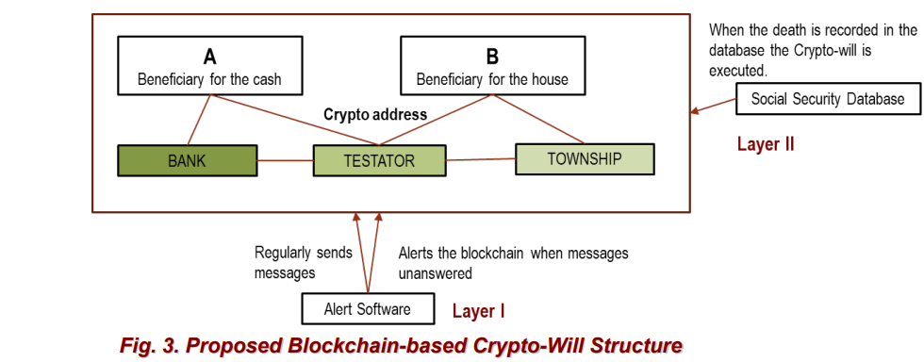

Discussion

For a Crypto-Will to be considered valid, it must adhere to certain conditions. Traditionally, a Will is required to be in writing, and in the case of a Crypto-Will, it is encrypted and stored in a block. Additionally, a conventional Will appoints an executor, while in a Crypto-Will, the software acts as the executor, ensuring asset distribution as specified in the Will. Two or more witnesses are typically required to attest a Will, validating its authenticity. In the context of a Crypto-Will, the decentralized and secure nature of the technology itself serves as the required witness. Moreover, a traditional paper-based Will needs to be stored in a secure location, whereas a Crypto-Will, with its blockchain features, offers both security and tamper-proof capabilities.

Crypto-Wills have garnered substantial attention due to the convenience, security, and flexibility offered by blockchain technology. These unique digital assets possess several advantages over traditional paper Wills.

Firstly, Crypto-Wills eliminate the vulnerabilities associated with physical documents. Unlike paper Wills, they cannot be damaged, lost, or stolen. Through blockchain technology, Crypto-Wills are transformed into unique, immutable, and time-stamped digital entities, ensuring heightened security compared to their conventional counterparts.

Furthermore, Crypto-Wills are highly resistant to alteration or tampering. The distributed nature of the blockchain network ensures that copies of the Will exist across multiple nodes. Any discrepancies between versions would be immediately flagged, maintaining the integrity and security of the document.

Privacy is also safeguarded with Crypto-Wills, as the identification of the testator and beneficiaries is solely based on their "crypto-addresses." This ensures confidentiality and restricts access to authorized parties.

When it comes to the execution of a Crypto-Will after the testator's death, a double screening process is employed. Both independent programs must confirm the death, ensuring a robust validation process. This negates the requirement for intermediaries such as executors, lawyers, or witnesses.

Moreover, the utilization of Crypto-Wills significantly reduces the probability of human errors, increasing their reliability. As a result, it is expected that the adoption and utilization of Crypto-Wills will accelerate at a rapid pace in the near future.

**Legislation References**

1. **H.R. 8373 (116th): Digital Commodity Exchange Act of 2020/** **https://www.govtrack.us/congress/bills/116/hr8373/text/ih**
2. **H.R. 1602 (117th): “Eliminate Barriers to Innovation Act of 2021”**

**https://www.congress.gov/117/bills/hr1602/BILLS-117hr1602rfs.xml**

1. **H.R. 3723 (117th): “Consumer Safety Technology Act” TITLE II—BLOCKCHAIN TECHNOLOGY INNOVATION**

**https://www.congress.gov/117/bills/hr3723/BILLS-117hr3723ih.xml**

1. **H.R. 8378(117th): “Securities Clarity Act”**

**https://www.congress.gov/bill/116th-congress/house-bill/8378/text?q=%7B%22search%22%3A%5B%22Securities+Clarity+Act%22%5D%7D&r=1&s=1**

1. **H.R. 5123(117th): “American Freedom and Internet Access Act of 2021”**

**https://www.congress.gov/bill/117th-congress/house-bill/5123/text?q=%7B%22search%22%3A%5B%22starfall%22%5D%7D&r=1&s=2**

1. **Executive Order on Ensuring Responsible Development of Digital Asset**

**https://www.whitehouse.gov/briefing-room/presidential-actions/2022/03/09/executive-order-on-ensuring-responsible-development-of-digital-assets/**